GEM Abstraction Manual

# **Download And Installation**

# **Launching GEM Cutter**

To start using GEM Cutter, go into the folder named “GEM Cutter III” and double-click on the Executable Jar File “GemCutter.jar”, as shown below.

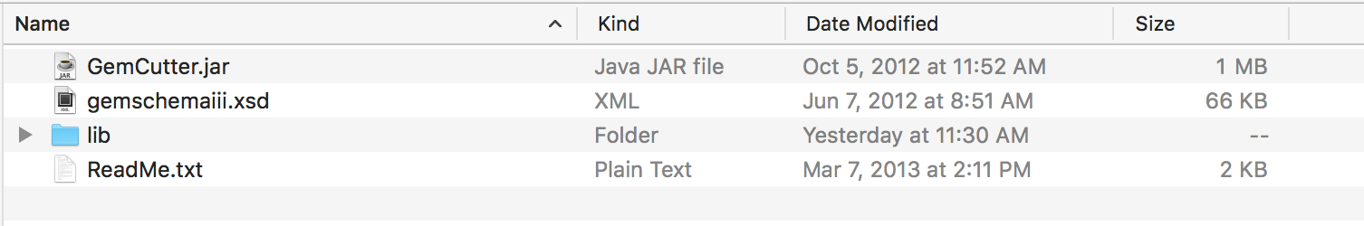

This will launch the GEM-Cutter application and the main screen **below** will appear.

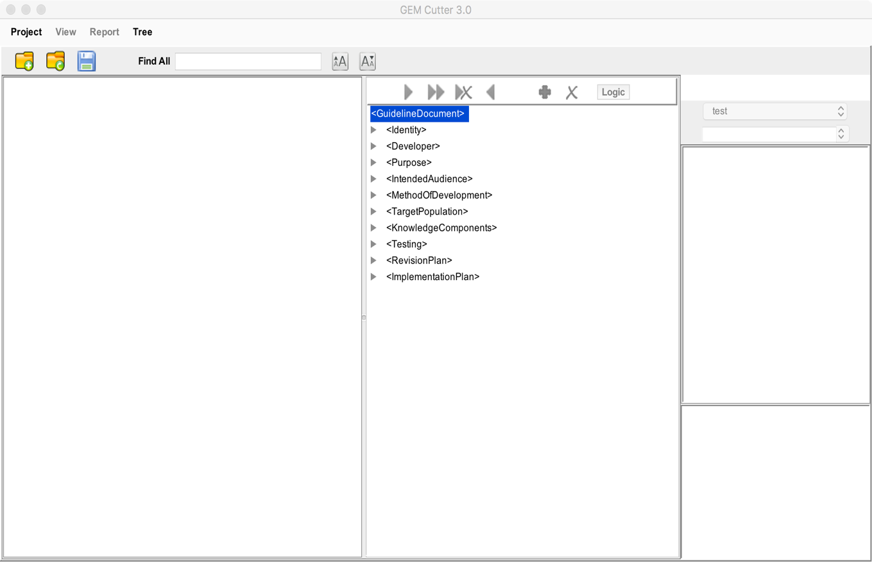

# **Beginning a New Project**

To begin cutting a guideline for the first time, click on “Project” at the top left of the menu bar and then select “New Project” from the drop-down menu. Alternatively, you can click on the “New Project” icon. (below left). The window shown at below right will appear.

|  |  |
| --- | --- |
|  |  |

Enter a name for the project which will permit easy identification. The use of spaces is not supported—use underscore (_) if necessary. Next click on the button with the ellipsis (…), which will allow you to browse your computer to find the file of the guideline you will be cutting. After you have identified and selected the full-text file of the guideline, click “Create Project”. The guideline document is loaded into the cutter and will be visible in the leftmost of the three main panels:

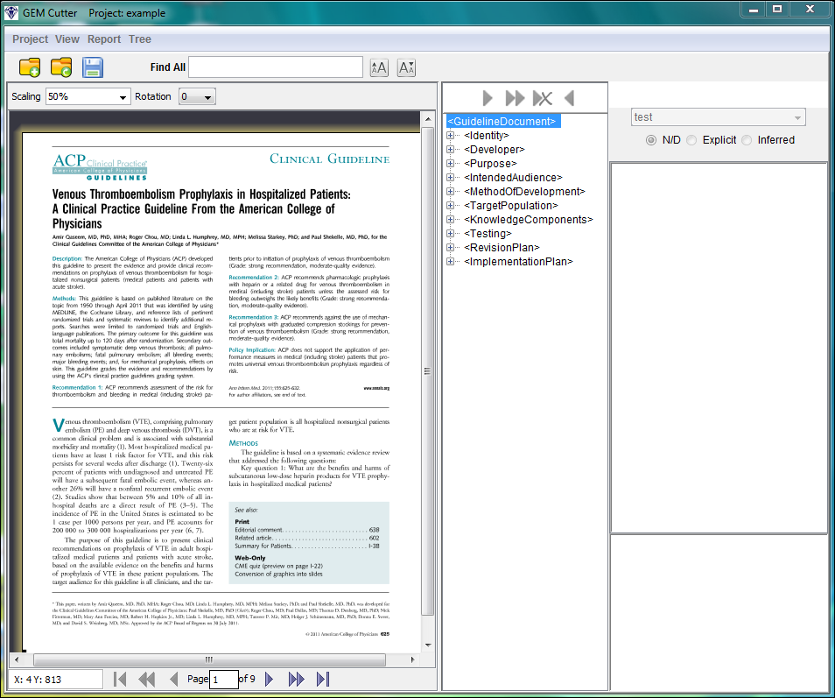

The middle panel displays a tree view of the GEM hierarchy, containing ten “top-level” elements (below left), which can be collapsed and expanded using the plus and minus icons (below middle). There is also a “Tree” feature available from the menu bar (below right), which provides two dropdown items: Expand All and Collapse All, which can be used to display all or none of the elements in the GEM tree (eliminating the need to individually/manually expand and collapse the items. If the tree is fully collapsed, double-clicking <GuidelineDocument> will show the ten next level elements.

|  |  |  |
| --- | --- | --- |
|  |  |  |

The GEM hierarchy provides the ability to capture over 100 “elements”, or unique types of information about the guideline. A listing of the elements and their definitions are listed below. A checkmark (“**🗸**”) denotes an element currently required to be GEM-cut. Note that elements containing coding information (e.g. Inclusion Criterion Code, Decision Variable Code) will be populated by indexers rather than GEM abstractors.

|  |  |  |
| --- | --- | --- |
| **Identity** | | |
| **🗸** | GEM Cut History | Record of GEM file creation |
| **🗸** | * GEM Cut Version | Identification details of the current instance of the GEM file |
| **🗸** | * + - GEM Cut Author | Individual responsible for creating this version of the GEM file |
| **🗸** | * + - GEM Cute Date | Date when this version of the GEM file was created |
| **🗸** | Guideline Title | Complete title of the guideline |
| **🗸** | Citation | Bibliographic citation |
|  | * Guideline Length | Number of pages in printed document |
| **🗸** | Release Date | Date the guideline was released to the public |
|  | Availability | Information regarding sources of a guideline and associated documentation |
|  | * Electronic | Information regarding sources of guideline in electronic format |
|  | * Print | Information regarding sources of guideline in print format |
|  | * Contact | Person or organization to contact for additional information about a guideline |
|  | Status | Statement of whether the guideline is original or a revised or updated version of a previously issued document |
|  | Companion Document | Refers to other documents (including Technical Reports, Consumer Guidelines, Quick Reference Guidelines) produced by the guideline developer relevant to the guideline |
|  | * Patient Resource | A patient-oriented summary of guideline content or a resource intended to assist patients with guideline application. |
|  | * Quick Reference Guide | A concise document that summarizes guideline recommendations for clinicians |
|  | * Technical Report | A document or document component that describes in detail the method of guideline development |
|  | Adaptation | Indicates that the guideline has been adapted from another guideline |
|  | Structured Abstract | A summary statement that describes a guideline using structured headings |
| **Developer** | | |
| **🗸** | Developer Name | Organization(s) responsible for developing the guideline |
|  | Committee Name | Formal name of committee within developer organization responsible for developing guideline |
|  | * Committee Expertise | Expertise present within the group that authored guideline |
|  | * Committee Member | Name of member of guideline development committee |
|  | * + - Member Conflict | A potential source of bias (e.g., financial or intellectual) related to a panelist or potential panelist that could influence the CPG development process |
|  | * + - Member Role | Expected function of a committee member, e.g., chair, epidemiologist, or implementation specialist |
|  | * + - Member Expertise | Professional expertise of individual guideline committee member |
|  | Funding | Source of financial support for guideline development |
|  | Endorser | Organization that has endorsed the guideline |
|  | Comparable Guideline | Another guideline on the same or similar topic |
|  | Role of Sponsor | The sponsor’s part in developing, modifying, and reporting the guideline |
|  | Conflict of Interest | Potential situations in which financial or other considerations may compromise, or have the appearance of compromising, a developer’s professional judgment |
| **🗸** | * COI Policy | Principles and strategies adopted by developer to address potential conflicts |
| **🗸** | * COI Disclosure | Report of potential and real conflicts of interest and how they are addressed |
| **Purpose** | | |
|  | Main Focus | Primary disease/condition, treatment/intervention, health practice, service, or technology addressed in the guideline main focus |
|  | Rationale | Reasons for developing recommendations including why the guideline was developed/needed, e.g., evidence of practice variation or inappropriate practice |
| **🗸** | Objective | General goals that implementation of the guideline is intended to bring about |
|  | Available Option | Principal alternative preventive, diagnostic, or therapeutic strategies considered |
|  | Health Outcome | The most important specific outcomes (health, economic, etc) considered in the guideline |
|  | Exception | Situations in which socially relevant factors permit an exception to be made in applying the guidelines; including home and family situation, constraints on health care delivery system |
| **Intended Audience** | | |
| **🗸** | Users | Intended users of guideline information |
| **🗸** | Care Setting | The settings in which the guideline is intended for use |
| **Method of Development** | | |
| **🗸** | Patient and Public Involvement | Role of patients, advocates, consumer organizations in guideline development and review |
|  | Description of Evidence Collection | A description of methods used to collect, identify, and retrieve scientific evidence on each question on which recommendations are based, including details on computer searches (including dates) and use of personal files and bibliographies |
|  | * Evidence Time Period | Publication date of earliest and most recent evidence considered |
|  | * Number of Source Documents | Number of source documents identified |
|  | * Evidence Selection Criteria | Methods used to choose the evidence that informs guideline development, including inclusion and exclusion criteria for specific studies |
|  | Description of Evidence Combination | Method of synthesis used to combine the scientific evidence quantitatively or otherwise |
|  | Cost Analysis | Describes any formal cost analysis performed |
|  | Specification of Harm(s) and Benefit(s) | Qualitative description of anticipated benefits and potential risks associated with implementation of guideline |
|  | Quantification of Harm(s) and Benefit(s) | Quantification of benefits or risks associated with implementation of guideline |
|  | Role of Value Judgment | Implicit or explicit process for judging relative desirability of health, economic, and process outcomes associated with alternative practices |
|  | Role of Patient Preference | Role of patient preferences for possible outcomes of care when the appropriateness of a clinical intervention involves a substantial element of personal choice or values |
|  | Qualifying Statement | Important caveat relating to a major recommendation. Identifies an area of uncertainty |
|  | Methods to Reach Judgment | Group judgment techniques used to reach judgment on recommendations; a description of how the developer made the transition from evidence to recommendation |
| **🗸** | Rating Scheme | Criteria for rating quality of evidence and/or strength of recommendation |
| **🗸** | * Evidence Quality Rating Scheme | Criteria for rating quality of evidence |
| **🗸** | * Recommendation Strength Rating Scheme | Criteria for rating strength of recommendation |
| **Target Population** | | |
| **🗸** | Eligibility | Describes population that the recommendations are intended to affect; identifies restrictions on guideline use such as within a managed care organization or geographic region |
| **🗸** | * Inclusion Criteria | A criterion whose presence is necessary for the guideline recommendations to be applicable |
| **🗸** | * + - Inclusion Criterion Code | An identifier selected from a standard terminology that describes an inclusion criterion |
| **🗸** | * Exclusion Criteria | A criterion whose presence excludes the applicability of the recommendations |
| **🗸** | * + - Exclusion Criterion Code | An identifier selected from a standard terminology that describes an exclusion criterion |
| **Knowledge Components** | | |
| **🗸** | Statement of Fact | A non-executable statement intended by the author to describe appropriate care. This category includes US Preventive Services Task Force “I Statements”, i.e., the authors conclude that there is insufficient evidence to support a recommendation for or against such an action |
| **🗸** | Recommendation | Statement of appropriate practice and the conditions under which it is to be undertaken. The statement is intended to influence practitioners' behavior and/or patient outcomes. A number or brief title for a specific recommendation should be stored in this element. |
| **🗸** | * Recommendation Notes | Additional comments related to the development of the recommendation |
| **🗸** | * Conditional | A recommendation applicable under circumstances specified by an if-then statement. The complete text of the conditional statement should be stored in this element |
| **🗸** | * + - Benefit Harm Assessment | The process (including values applied) and the outcome of weighing benefits against risks, harms, and costs that expresses equilibrium or net benefit or harm. |
| **🗸** | * + - Decision Variable | A condition that must be tested to indicate the appropriateness of a conditional recommendation. Store only a single variable in each decision variable element |
| **🗸** | * + - * Decision Variable Code | Identifier selected from a standard terminology that describes a decision variable |
|  | * + - * Value | A specified state of a decision variable |
| **🗸** | * + - * Decision Variable Description | Text that provides and amplifies information about a decision variable |
|  | * + - * Test Parameter | Information about the quality of a decision variable |
|  | * Sensitivity | An indication of the probability of the decision variable being present under specific clinical circumstances |
|  | * Specificity | An indication of the probability of the decision variable being absent under specific clinical circumstances |
|  | * Predictive Value | An indication of the probability of an outcome occurring when a particular value of the decision variable is present |
|  | * + - * Decision Variable Cost | The cost of testing a decision variable |
| **🗸** | * + - Action | Appropriate activity to be carried out given the specific circumstances defined by values of decision variables. Store only a single action in each Action element |
| **🗸** | * + - * Action Benefit | An improvement in status of some measured outcome that may occur as a result of following a recommendation |
| **🗸** | * + - * Action Risk Harm | Risk or adverse outcome associated with a specified action |
| **🗸** | * + - * Action Actor | The person(s) or role intended to carry out the recommended activity |
| **🗸** | * + - * Action Verb | The word or phrase in a recommendation that expresses action, state, or relationship |
| **🗸** | * + - * Action Deontic Term | The word or phrase that defines the level of obligation of an active or directive |
| **🗸** | * + - * Action Verb Complement | Word or phrase that completes the sense of a verb and includes direct and indirect objects |
| **🗸** | * + - * Action Code | Identifier selected from a standard terminology that describes an action or directive |
| **🗸** | * + - * Action Description | Text that provides and amplifies information about an action |
| **🗸** | * Intentional Vagueness | An indication of the reason for deliberate underspecification of a recommendation’s conditions or actions |
|  | * + - * Action Cost | Cost of performing a specific action |
|  | * + - * Action Value | A specified state of an action |
|  | * + - * Action Type | A categorization of activity directed by a conditional |
| **🗸** | * + - Reason | An explanation or justification for a recommendation |
| **🗸** | * + - Evidence Quality | An indication of methodologic rigor of the studies that support the specified recommendation |
| **🗸** | * + - * Evidence Quality Description | Description of the applicability, quantity (including completeness) and consistency of the aggregate available evidence. It may include an explanation of the part played by values, opinion, theory, and clinical experience in deriving the recommendation |
| **🗸** | * + - * Disagreement | Description and explanation of any differences of opinion regarding the recommendation, including minority report |
| **🗸** | * + - Recommendation Strength | An indication of the guideline developers' level of support for a given recommendation |
| **🗸** | * + - * Recommendation Strength Code | Identifier selected from a standard terminology that describes the recommendation strength |
|  | * + - Flexibility | Indication of options in performing imperative |
| **🗸** | * + - Logic | Boolean operators that indicate how directives are to be combined |
|  | * + - Cost | Overall cost of performing this recommendation |
|  | * + - Linkage | Indicator of a relationship between this recommendation and other knowledge component(s) |
|  | * + - Reference | Specific citation relevant to this imperative recommendation |
|  | * + - Certainty | Indication of the likelihood that this recommendation will lead to specified outcomes |
|  | * + - Goal | The state that a recommendation is intended to achieve, maintain, or avoid |
| **🗸** | * Imperative | Recommendation directed at the entire target population without limitation. The complete text of the imperative statement should be stored in this element |
| **🗸** | * + - Benefit Harm Assessment | The process (including values applied) and the outcome of weighing benefits against risks, harms, and costs that expresses equilibrium or net benefit or harm. |
|  | * + - Scope | Implicit eligibility criteria for an imperative statement |
| **🗸** | * + - * Scope Code | Identifier selected from a standard terminology that describes the scope |
|  | * + - Directive | An appropriate activity for the eligible population. Store only a single activity in each Directive element |
| **🗸** | * + - * Directive Benefit | An improvement in status that may occur as a result of following a directive |
| **🗸** | * + - * Directive Risk Harm | Risk or adverse outcome associated with implementation of a directive |
| **🗸** | * + - * Directive Actor | The person(s) or role intended to carry out the recommended activity |
| **🗸** | * + - * Directive Verb | The word or phrase in a recommendation that expresses action, state, or relationship |
| **🗸** | * + - * Directive Deontic Term | The word or phrase that defines the level of obligation of an active or directive |
| **🗸** | * + - * Directive Verb Complement | Word or phrase that completes the sense of a verb and includes direct and indirect objects |
| **🗸** | * + - * Directive Code | Identifier selected from a standard terminology that describes an action or directive |
| **🗸** | * + - * Directive Description | Text that provides and amplifies information about a directive |
| **🗸** | * Intentional Vagueness | An indication of the reason for deliberate underspecification of a recommendation’s conditions or actions |
|  | * + - * Directive Cost | Cost of performing a specific directive |
|  | * + - * Directive Value | The specified state of a directive |
|  | * + - * Directive Type | A categorization of activity directed by an imperative |
| **🗸** | * + - Reason | An explanation or justification for a recommendation |
| **🗸** | * + - Evidence Quality | An indication of methodologic rigor of the studies that support the specified recommendation |
| **🗸** | * + - Recommendation Strength | An indication of the guideline developers' level of support for a given recommendation |
| **🗸** | * + - * Recommendation Strength Code | Identifier selected from a standard terminology that describes the recommendation strength |
|  | * + - Flexibility | Indication of options in performing imperative |
| **🗸** | * + - Logic | Boolean operators that indicate how directives are to be combined |
|  | * + - Cost | Overall cost of performing this recommendation |
|  | * + - Linkage | Indicator of a relationship between this recommendation and other knowledge component(s) |
|  | * + - Reference | Specific citation relevant to this imperative recommendation |
|  | * + - Certainty | Indication of the likelihood that this recommendation will lead to specified outcomes |
|  | * + - Goal | The state that a recommendation is intended to achieve, maintain, or avoid |
| **🗸** | Definition | Concise description of terminology relevant to the guideline |
| **🗸** | * Term | A word or phrase defined in the guideline |
| **🗸** | * + - Term Meaning | Precise meaning of words and phrases that may be unfamiliar to guideline readers; terms are defined as used in this guideline context |
|  | Algorithm | A flowchart representation of the stages and activities in health management described by the guideline |
|  | * Action Step | Specifies clinical actions that are to be performed in the patient-care process (GLIF) |
|  | * Conditional Step | Directs flow from one guideline step to another based on the evaluation of a criterion (GLIF) |
|  | * Branch Step | Directs flow in alternate directions (GLIF) |
|  | * Synchronization Step | Synchronization Step represents a convergence of other steps (GLIF) |
|  | Research Agenda | Proposal for further scientific investigation to correct identified deficiencies in the evidence base for this guideline topic |
|  | Background Information | Information relevant to the guideline’s topic but not related to other Knowledge Components |
| **Testing** | | |
|  | External Review | Methods of eliciting peer review comments and vetting guideline draft |
|  | Pilot Testing | Preliminary validation testing |
|  | Formal Appraisal | Evaluation of the guideline draft to appraise its validity and usability (e.g., COGS), quality (e.g., AGREE) and implementability (e.g., GLIA) |
| **Revision Plan** | | |
|  | Expiration | Time (or date) that recommendations cease to be valid |
|  | Scheduled Review | Future time (or date) planned to review continued appropriateness of recommendations |
| **Implementation Plan** | | |
|  | Implementation Strategy | Specific plans for implementing the recommendations |
|  | Anticipated Barrier | A factor that might be expected to impede operationalization of the guideline |
|  | Anticipated Enabler | A factor that might be expected to promote operationalization of the guideline |
|  | Performance Measure | Guideline-derived tool to measure the quality of care they provide by defining specific, measurable elements |

# **Starting to GEM-Cut**

To get started, identify guideline text that you would like to cut, then select it as shown below:

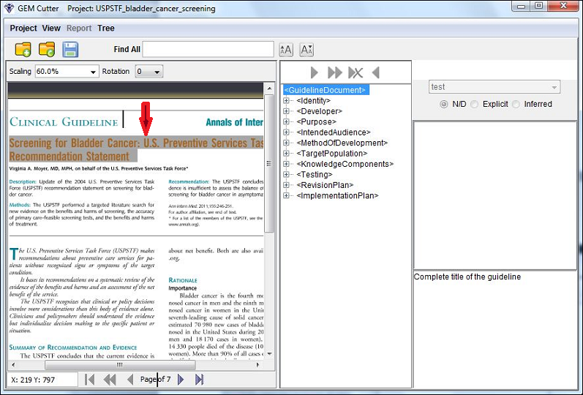

Next, select the element in the tree view that pertains to this text, e.g., <GuidelineTitle> as shown below. Note that in the bottom right-hand corner a definition of the element selected will be displayed, which can be used to ensure that you are capturing the appropriate text for that element.

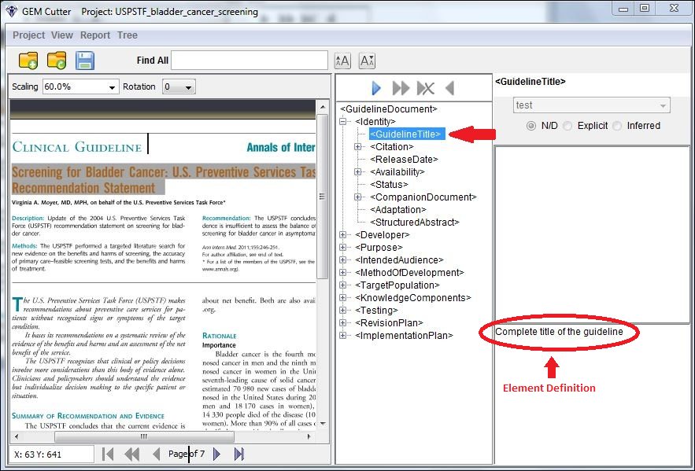

Finally, click on the first arrow button as shown below (“hovering” with your mouse above this button will read “Move Text”).

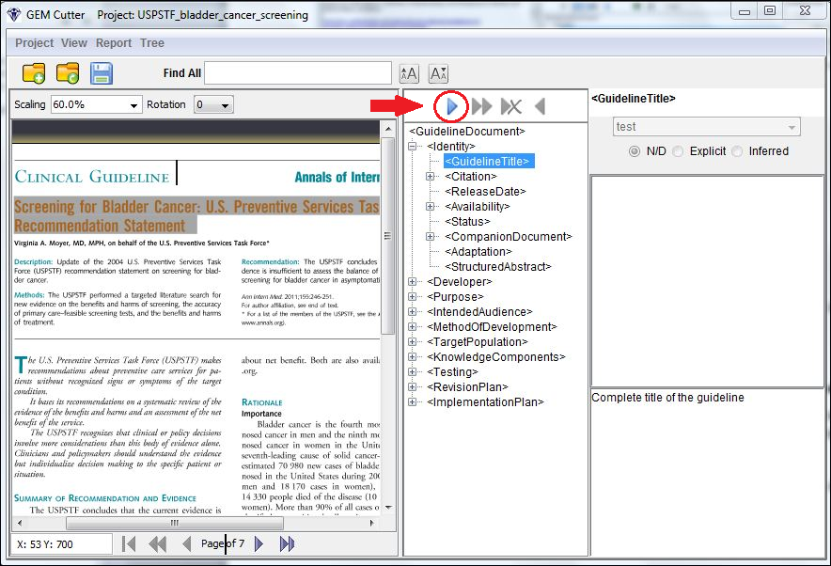

The text will be moved into the text box on the right.

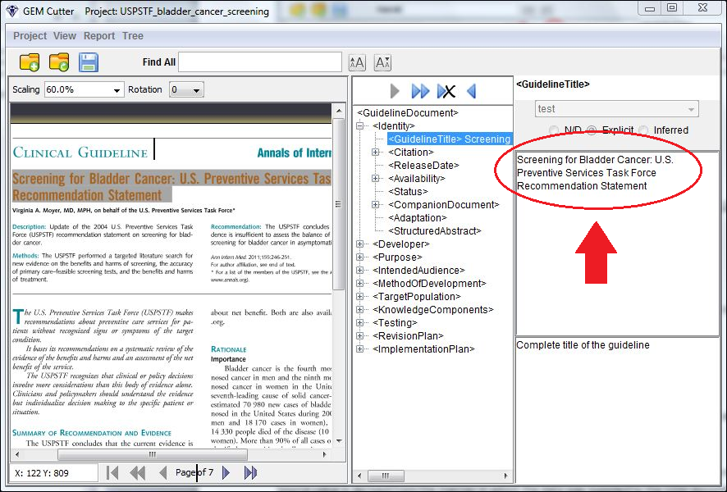

You can edit the text in the text box, if you wish to make changes to the original guideline text. If you choose to edit text, the button above the text box will move to Inferred, indicating in the XML document that this text is not the original, but has been modified. In addition to the “Move Text” button, the additional below features are available:

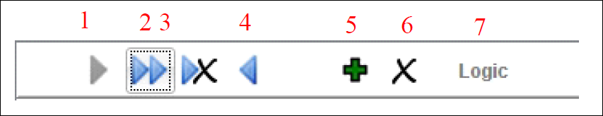

1. Move Text - Inserts the currently selected text into the tree view

2. Append Text - Adds the selected text to the end of the existing element text

3. Overwrite Text - Replaces the existing text in the tree view with the selected text

4. Remove Text – Erases the contents of the element in the tree view

5. Create Subtree – Makes a copy of the currently selected element in the tree view and its child elements

6. Remove Subtree – Deletes the currently selected element in the tree view and its child elements

7. Logic - Displays the Logic Window to assist in writing to the Logic Element. Detailed instructions for using the Logic feature are provided below in this document.

# **Populating the Logic Element**

The Logic button (#7 in the above diagram), will become “active” if the Conditional or Imperative element in the tree is selected. By clicking on the button, the Logic Window, shown below, will be displayed.

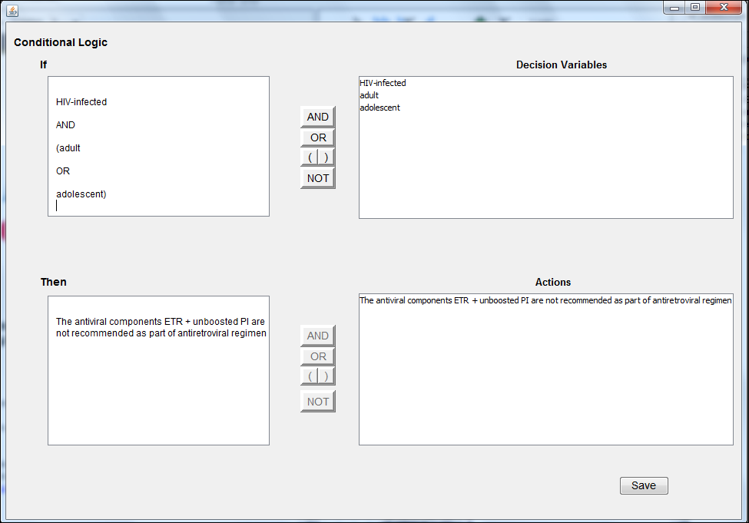

This window displays an "If" box, which contains a list of the decision variables for recommendations cut as Conditional (this box is blank for Imperatives). To the left is a vertical row of buttons that will insert the text on the button where the cursor is located in the text area. The same applies to the lower "Then" box, but here the Actions are listed for for a Conditional, Directives for an Imperative. To Save the logic, select the Save button in the lower right.

# **Saving and Reopening a Project**

When you are finished GEM-cutting, to save the file, select Project from the menu bar and then “Save Project”. Alternatively, you can click on the icon of the disk (below left). A screen like the one at below right should appear:

|  |  |
| --- | --- |
|  |  |

This action saves the project file as well as the GEM XML file. You can continue to GEM-cut the guideline, or exit the program. To use the program with a previously created project file, select Project and the Open Project menu item. The screen below will appear:



Click on the button with the ellipsis and navigate to your existing project folder. Select the file with .zip attached to the name of your project and press the Select button. Now select the Open Project button shown above. You should now be able to work on your previously started project.

# **Generating Reports**

When you are finished GEM-cutting a guideline, the GEM-Cutter tool provides the ability to generate a variety of different reports, which capture and display the guideline information in different ways. The third menu bar item is Report. This item contains six menu choices.

1. **Extractor-Detailed**. By selecting this view, a screen showing the extracted version of the current GEM document is displayed.

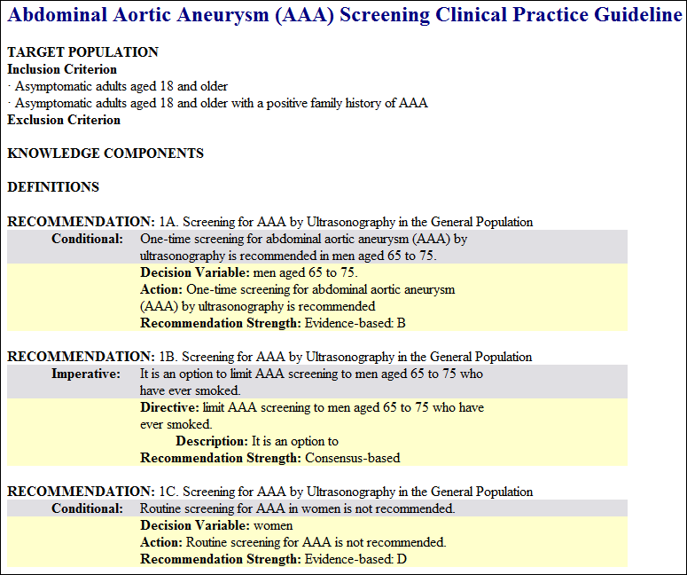

1. **Extractor-Rules**. In this report the guideline recommendations are stated in full and parsed into imperative and conditional statements, followed by a restatement as IF…THEN rules (IF decision variables…THEN actions) or as directives (IF a member of the Target Population…THEN directive). Blocks are included in the report in which decidability and executability can be commented upon and vocabulary codes for the parsed components may be entered.

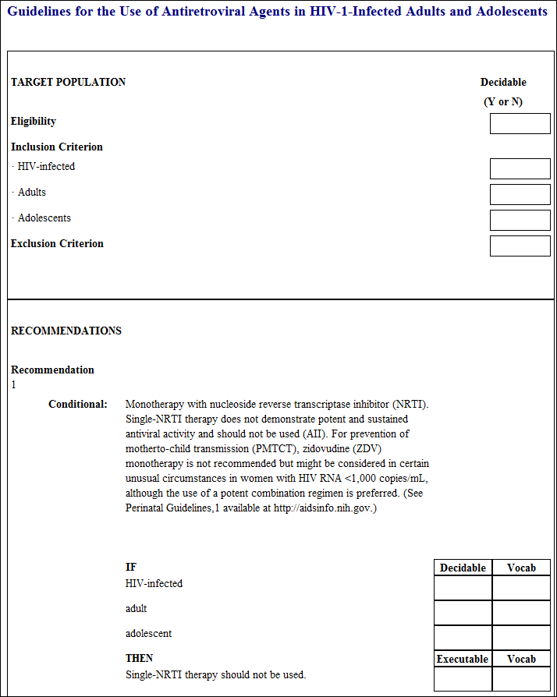

1. **Decision Variables**. In this report, all of the decision variables are removed from guideline context and presented in a list. This report offers an enhanced opportunity to judge and identify vagueness, underspecification, and decidability. It also provides (1) a comprehensive list of “trigger items” for decision support activities and (2) measurable starting points for evaluation.

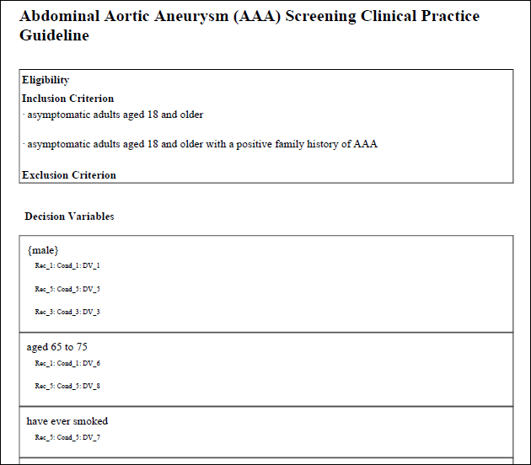

1. **Actions**. All of the actions (and directives) are removed from guideline context and presented in a list. This report offers This report offers an enhanced opportunity to judge and identify vagueness, underspecification, and decidability. It also provides (1) a comprehensive list of activities that will need to be addressed in the design of decision support systems activities and (2) a listing of potentially measurable actions.

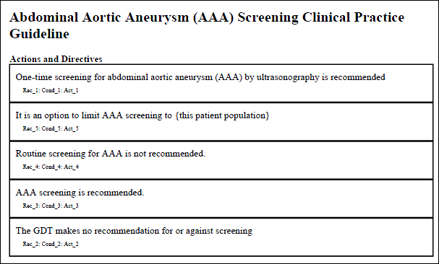

1. **GEM-COGS**. This will show the elements in the current GEM II document that satisfy the COGS checklist. To learn more about COGS, you can visit the web site at <http://gem.med.yale.edu/cogs>.
2. **XML**. The last option in the Report menu is “View XML”, which will display the current version of the XML file. The actual XML report is automatically generated by the GEM-Cutter tool when the project is saved by the user, and can be found in the folder corresponding to that guideline project (see below).

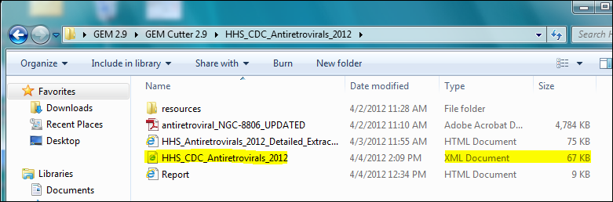

The format of the output will look similar to that below:

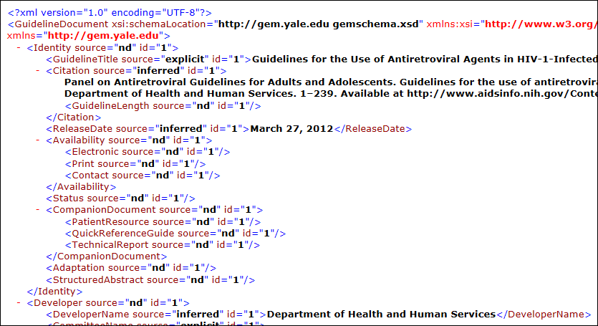

1. **Recommendations.** This output can be generated by using the Gem Extractor (available at <http://gem.med.yale.edu/GEMTools/gem_ii_tools.htm>).In this report the text of the guideline recommendations is extracted and presented in full text. In effect, this view represents an Executive Summary of actionable statements from the guideline.

.